***Gergo Nagy - Project Unit - Evidence (SQA PDA: Software Development)***

P 5 Site Map

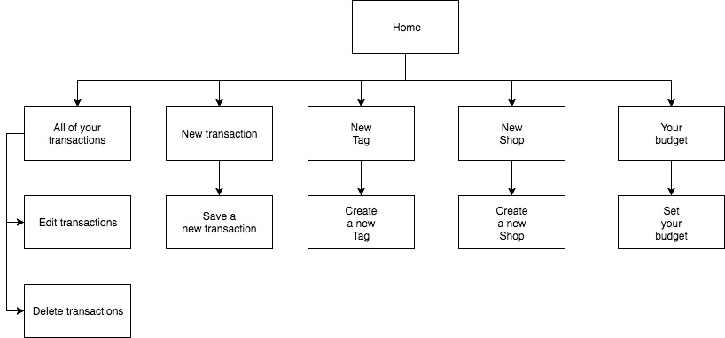

P 6 Wireframe:

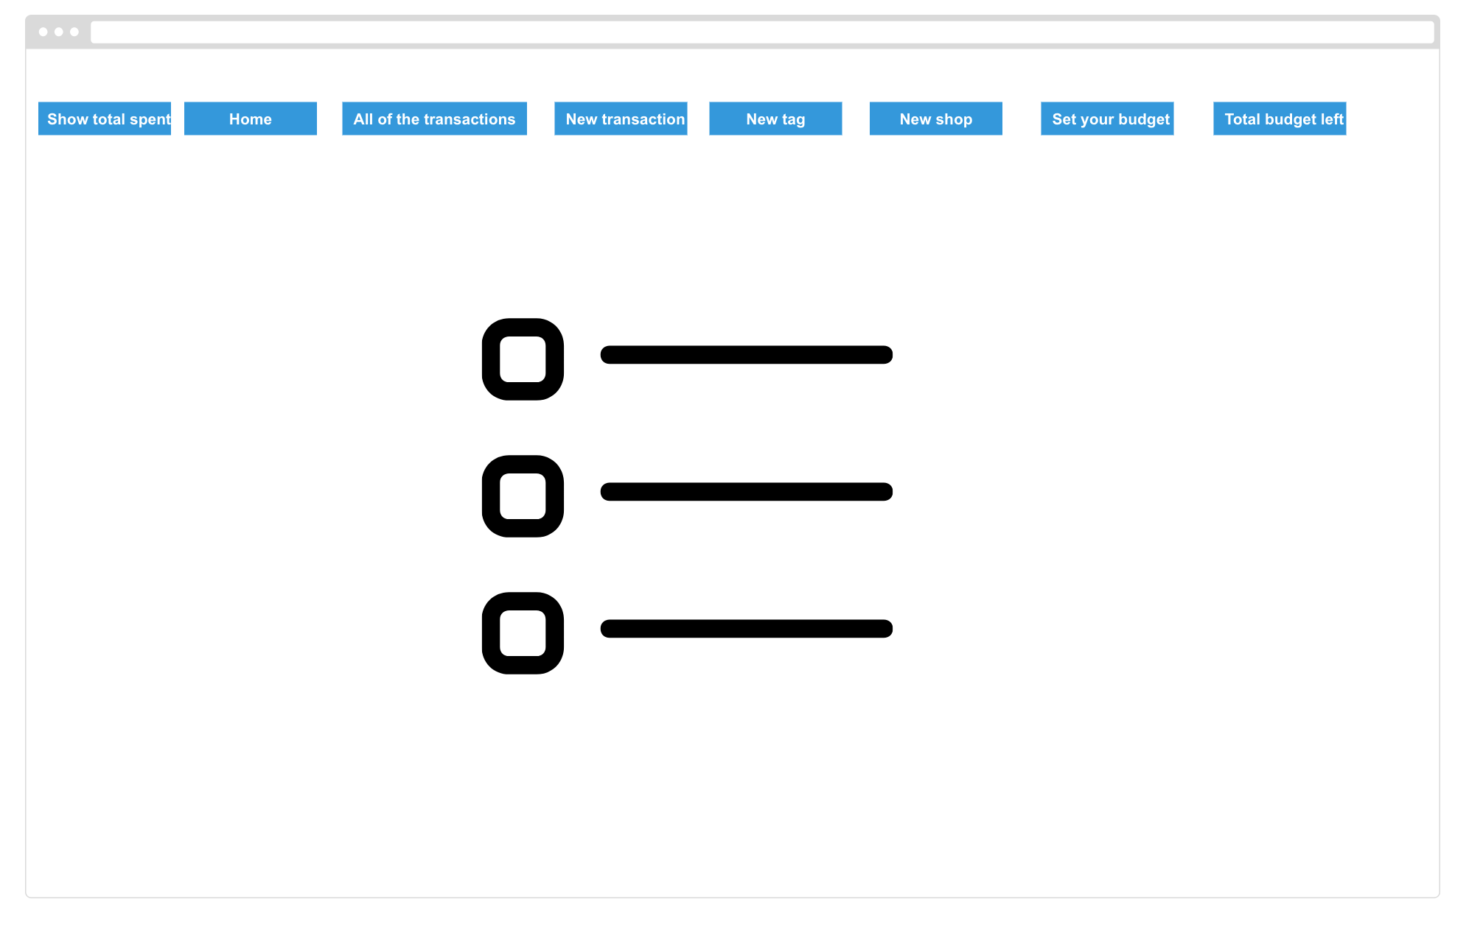

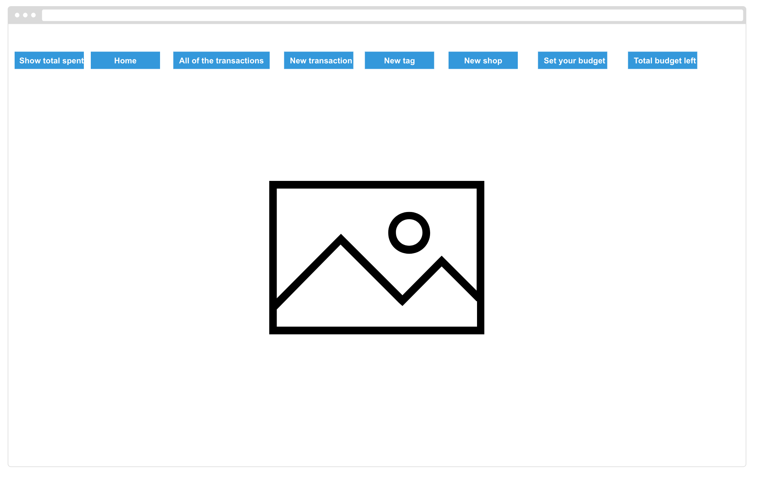

P 10 Pseudocode

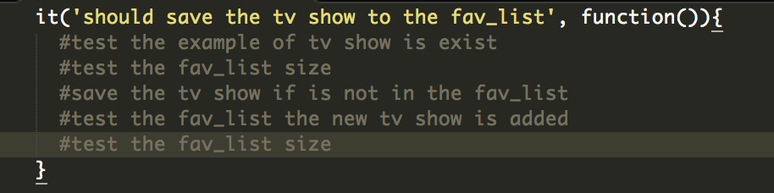

P 11 Project in Github

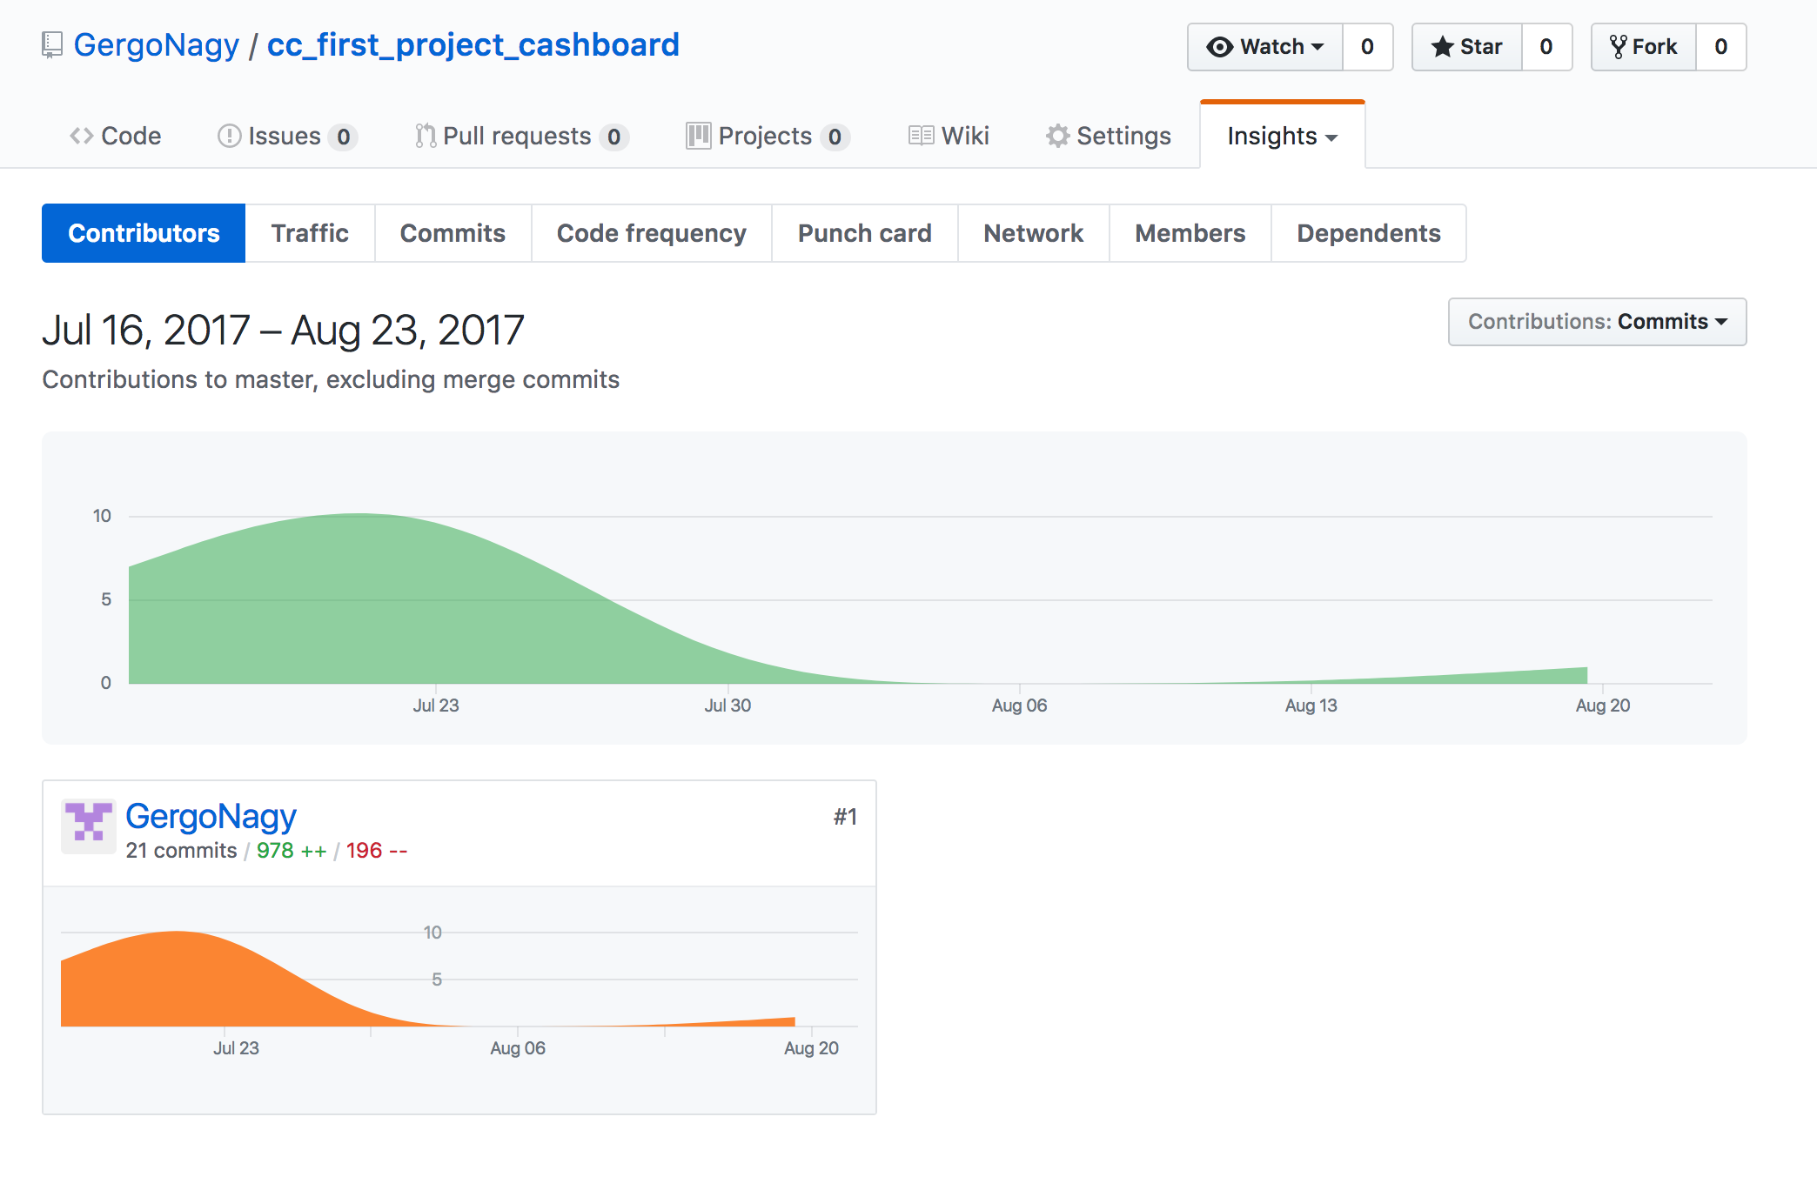

P 12 Planning stages

Stage 1:

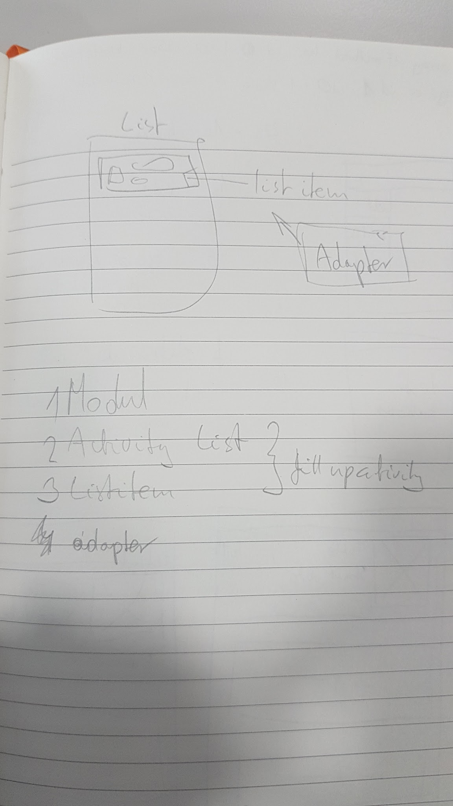

Stage 2:

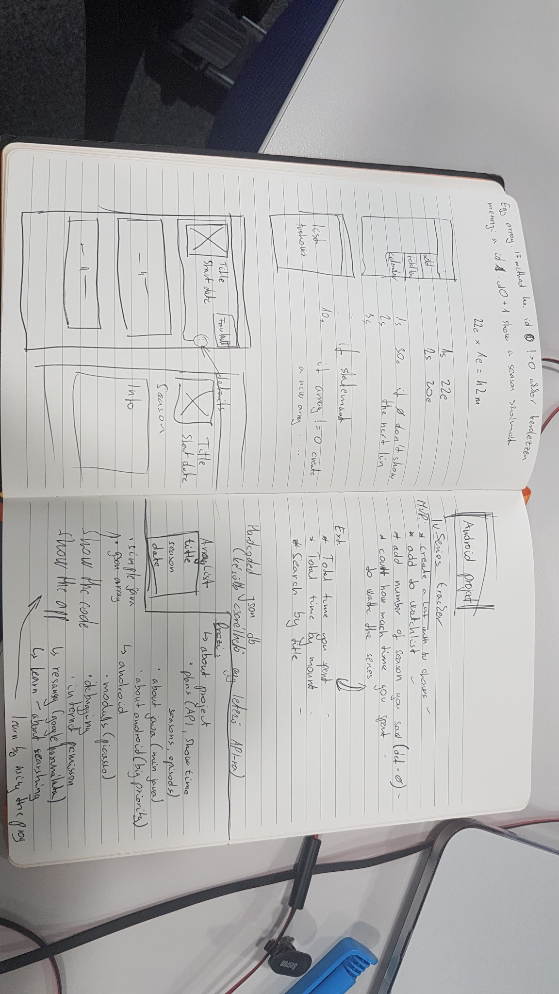

P 13 Show user input being processed according to design requirements:

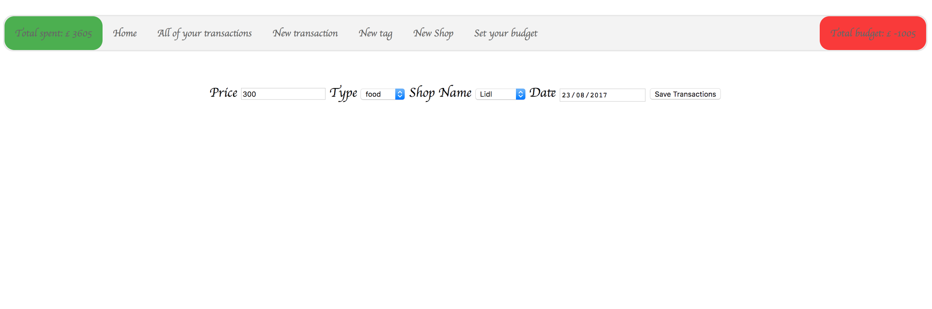

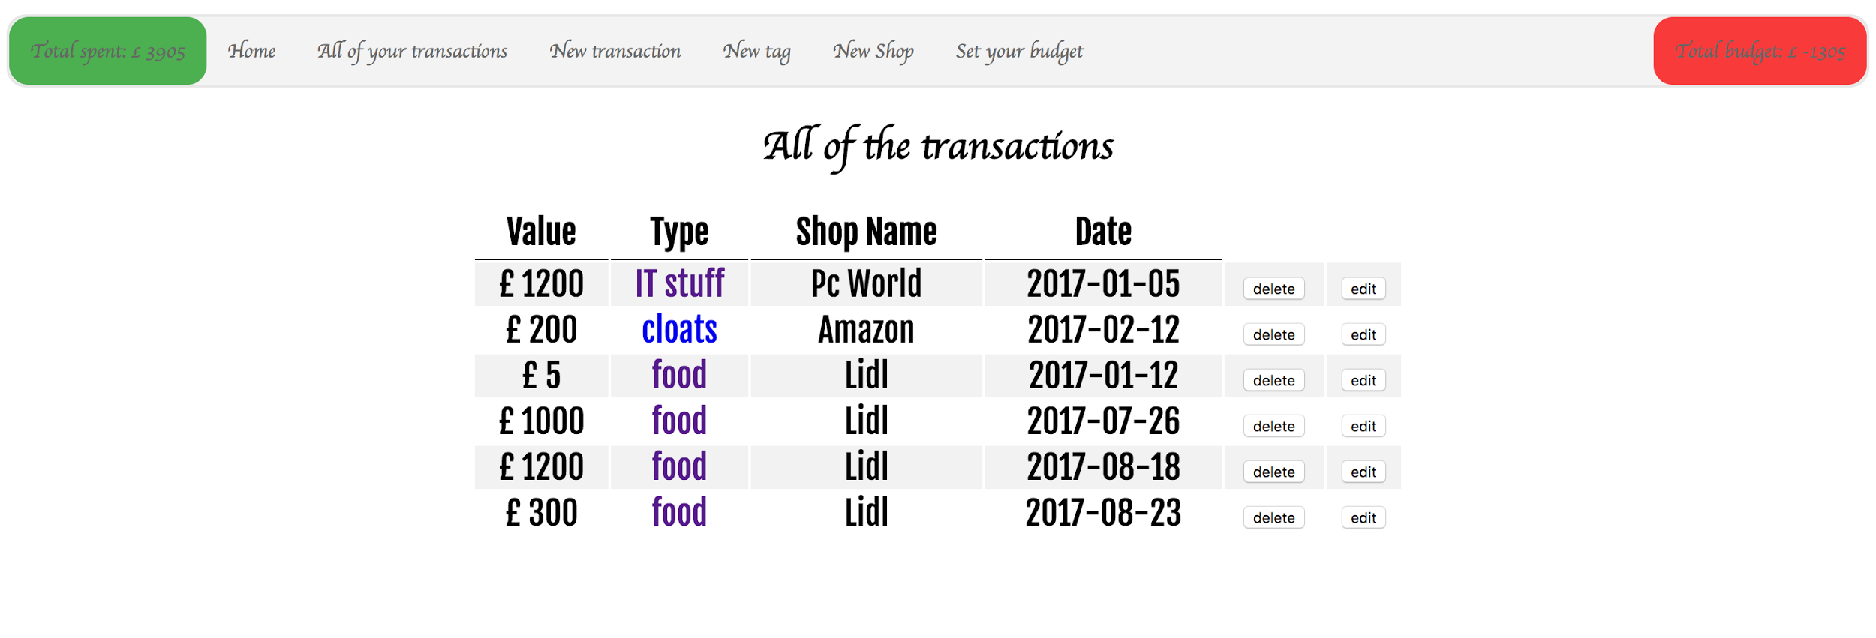

P 14 Show an interaction with data persistence:

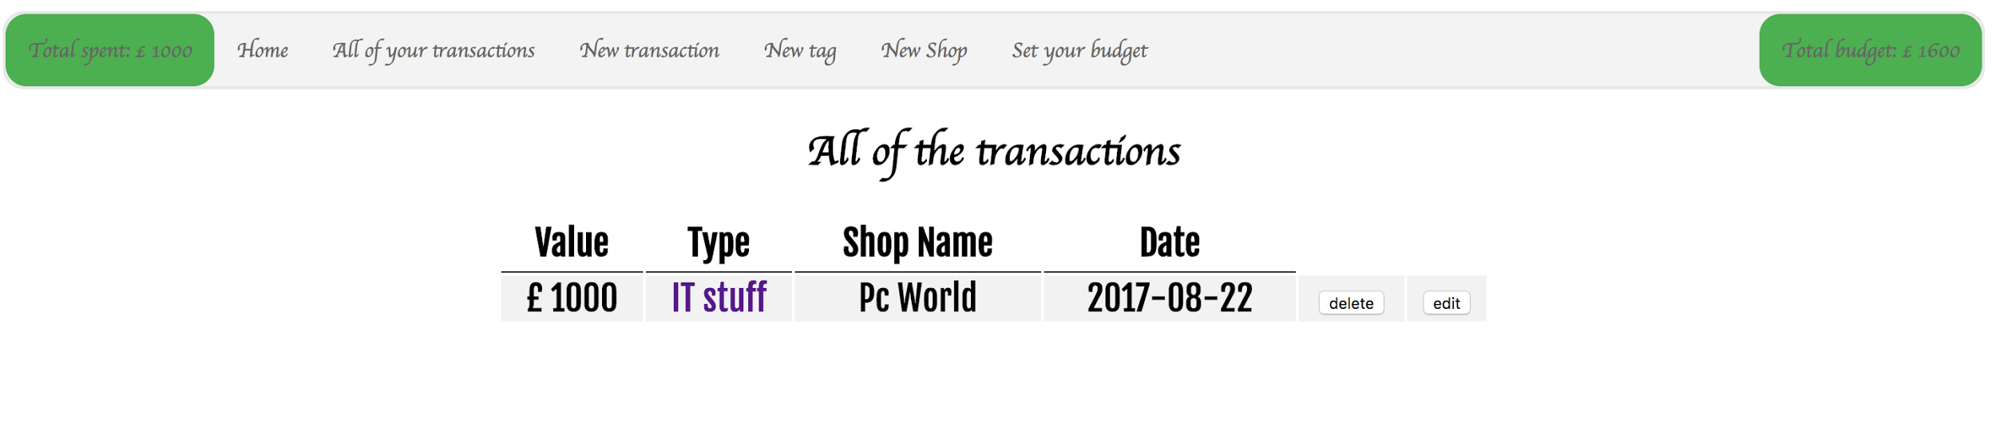

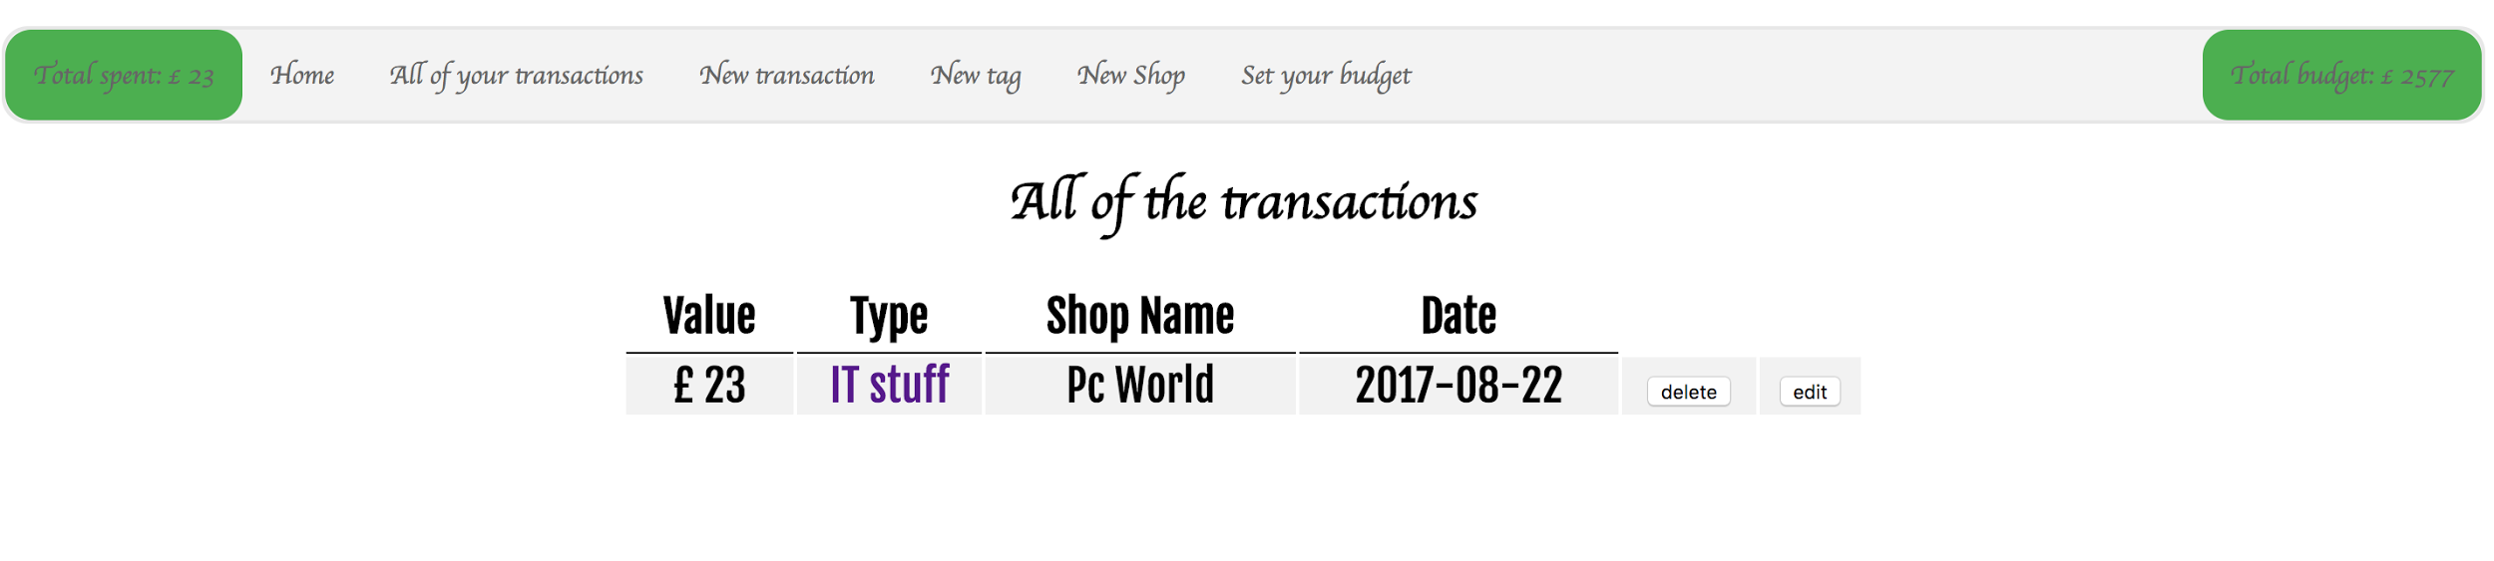

P 15 Show the correct output of results and feedback to user:

